- Weekly Review & Practice Practical

Q1. On Cisco Packet Tracer, create a network with three switches and assign at least two different VLANs (e.g., VLAN 10 for 'Sales', VLAN 20 for 'Support'). Connect two PCs to each switch and assign each PC to the correct VLAN based on department?

Answer
- I created VLAN 10 (Sales) and VLAN 20 (Support) on three Cisco 2960 switches.
- I assigned FastEthernet0/2 to VLAN 10 and FastEthernet0/3 to VLAN 20 on each switch.
- I verified the VLAN configuration using the show vlan brief command.
- Both VLANs were successfully created and activated on all three switches.
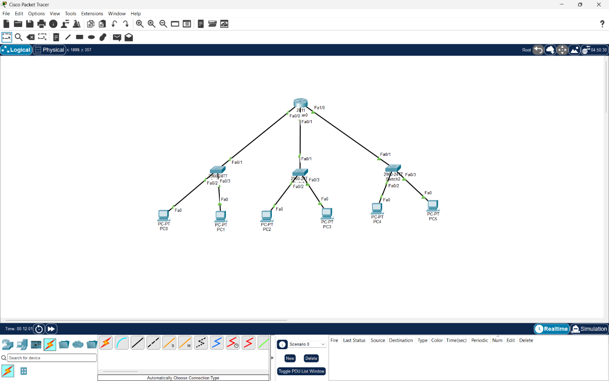

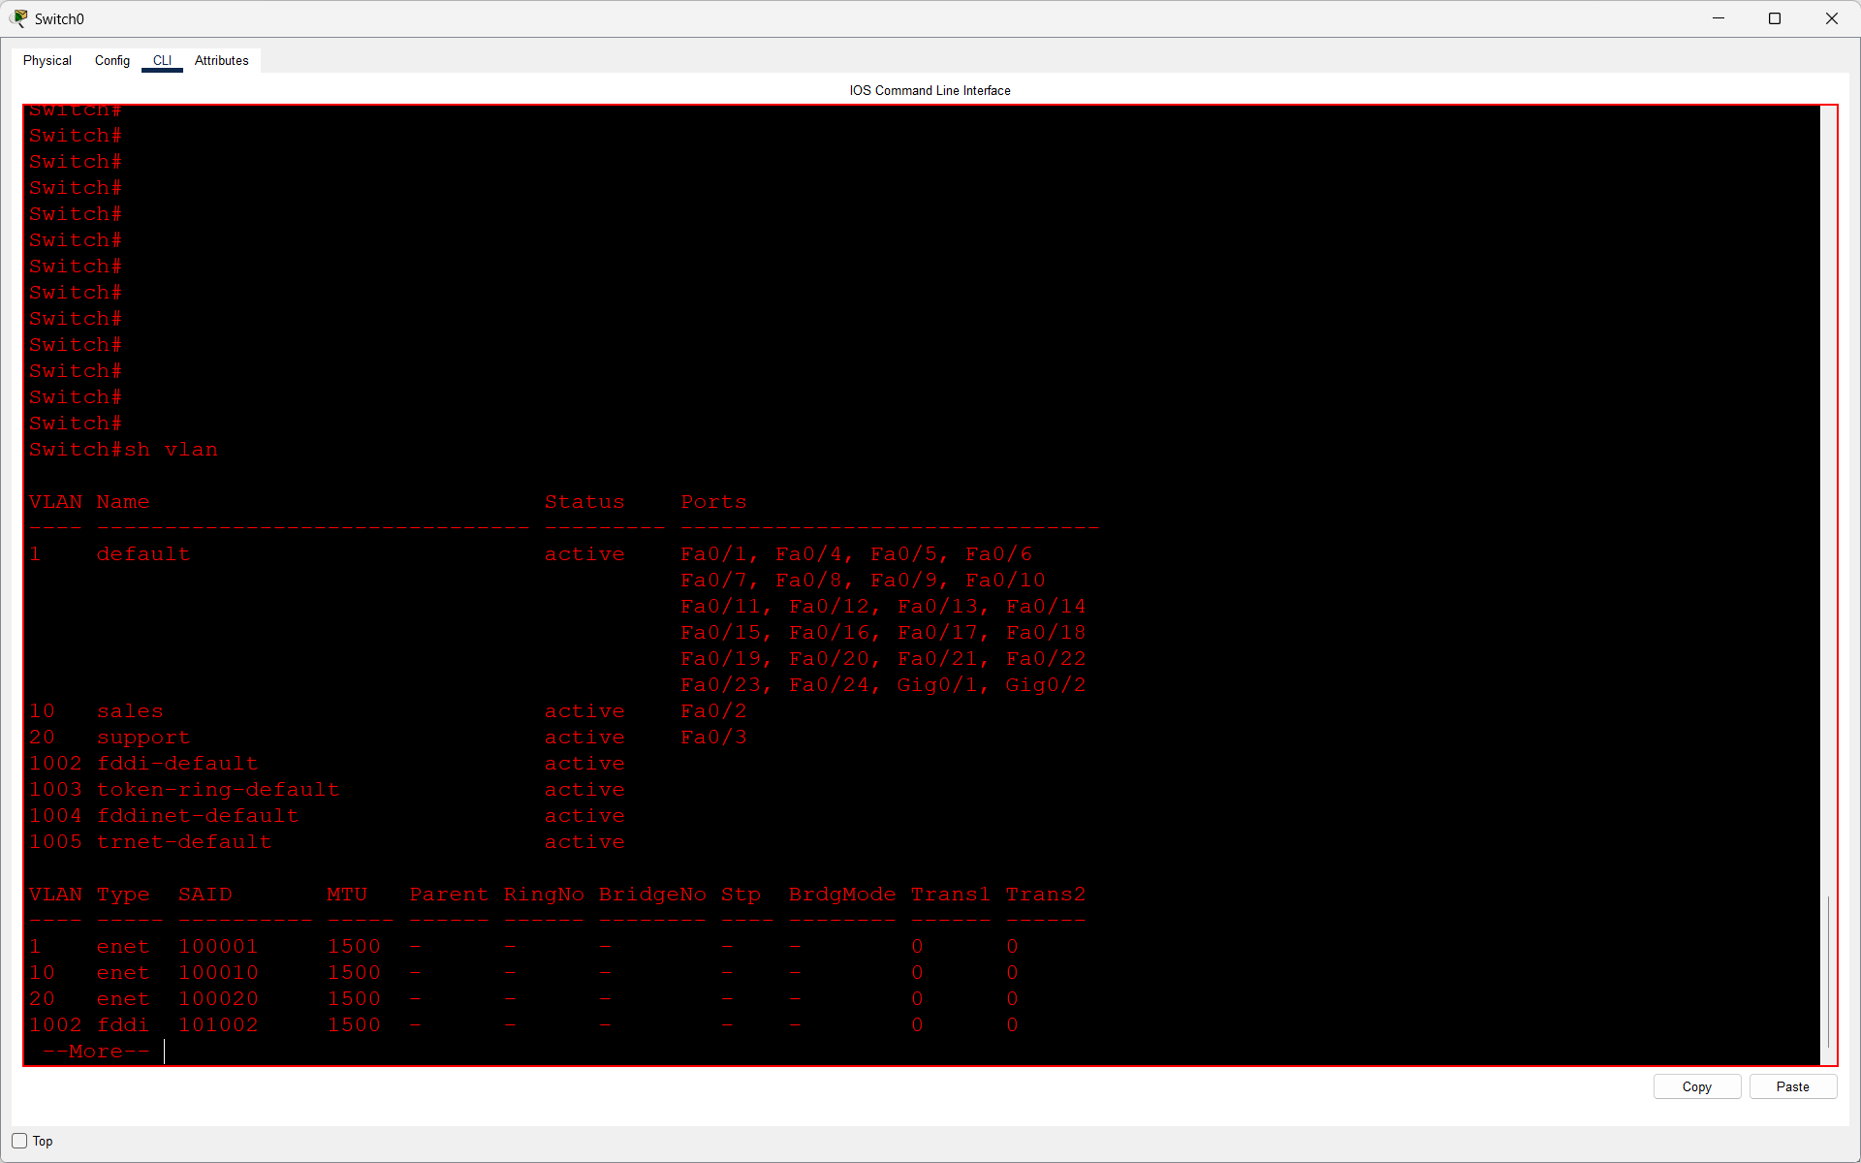
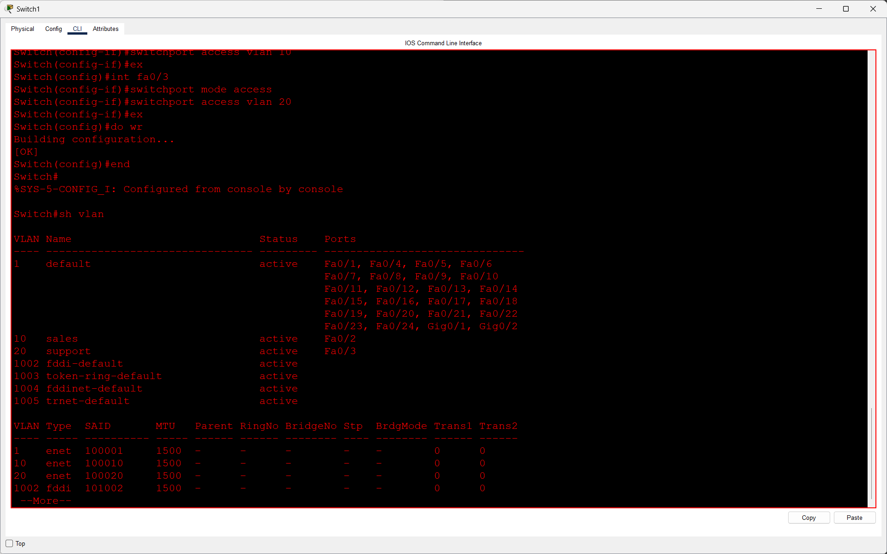
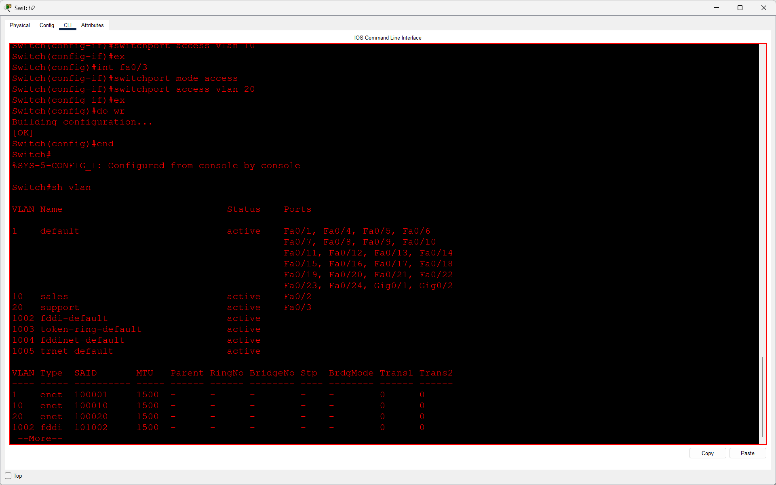

Q2. Configure trunk ports between the switches to allow VLAN traffic to pass through. Verify trunking by using the show interfaces trunk command and submit a screenshot of the output?

Answer
- I configured trunk ports between three switches using the switchport mode trunk command.
- I used 802.1Q trunking to allow VLAN 10 and VLAN 20 traffic between switches.
- I verified the configuration using the show interfaces trunk command.
- All three switches showed their configured ports in trunking mode.

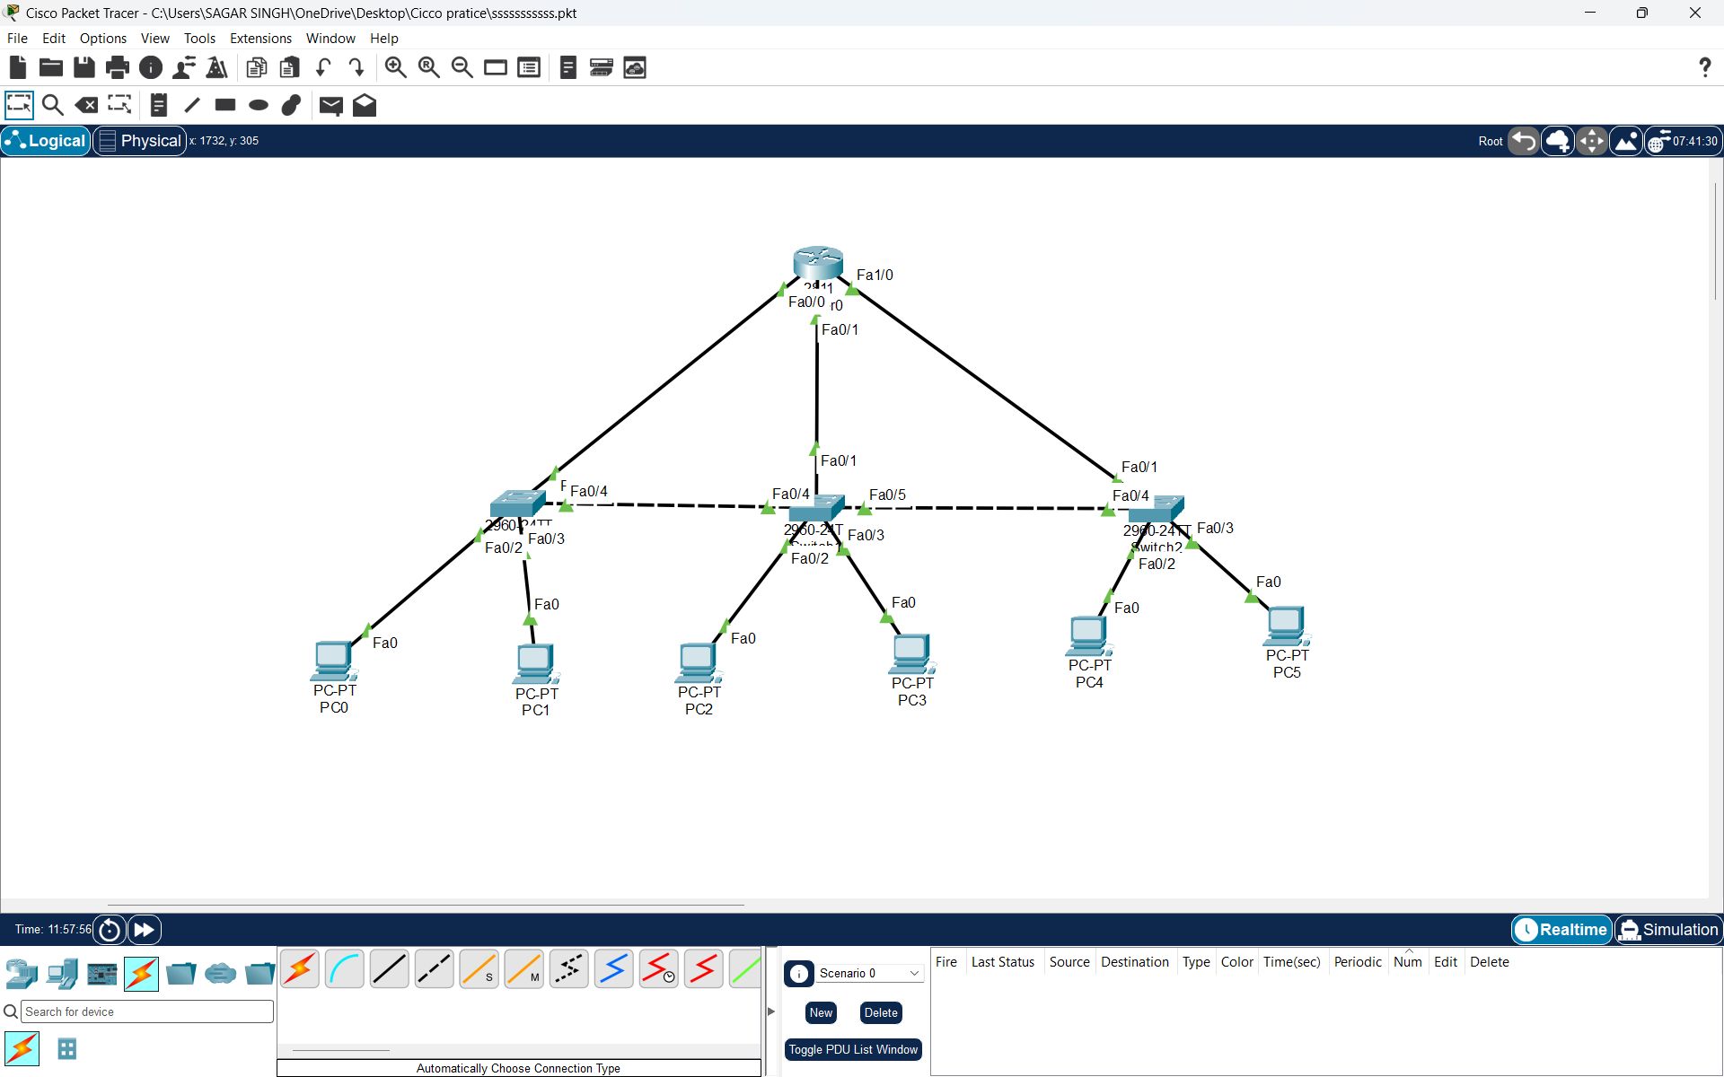
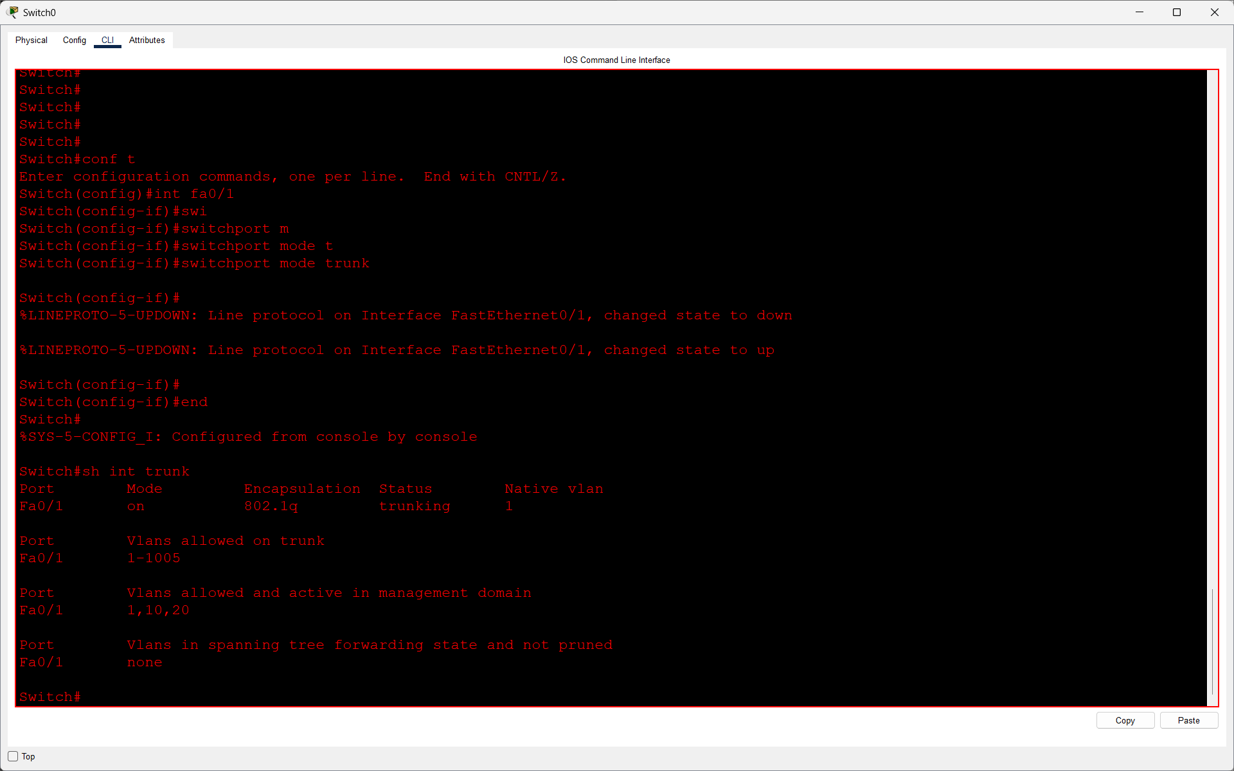
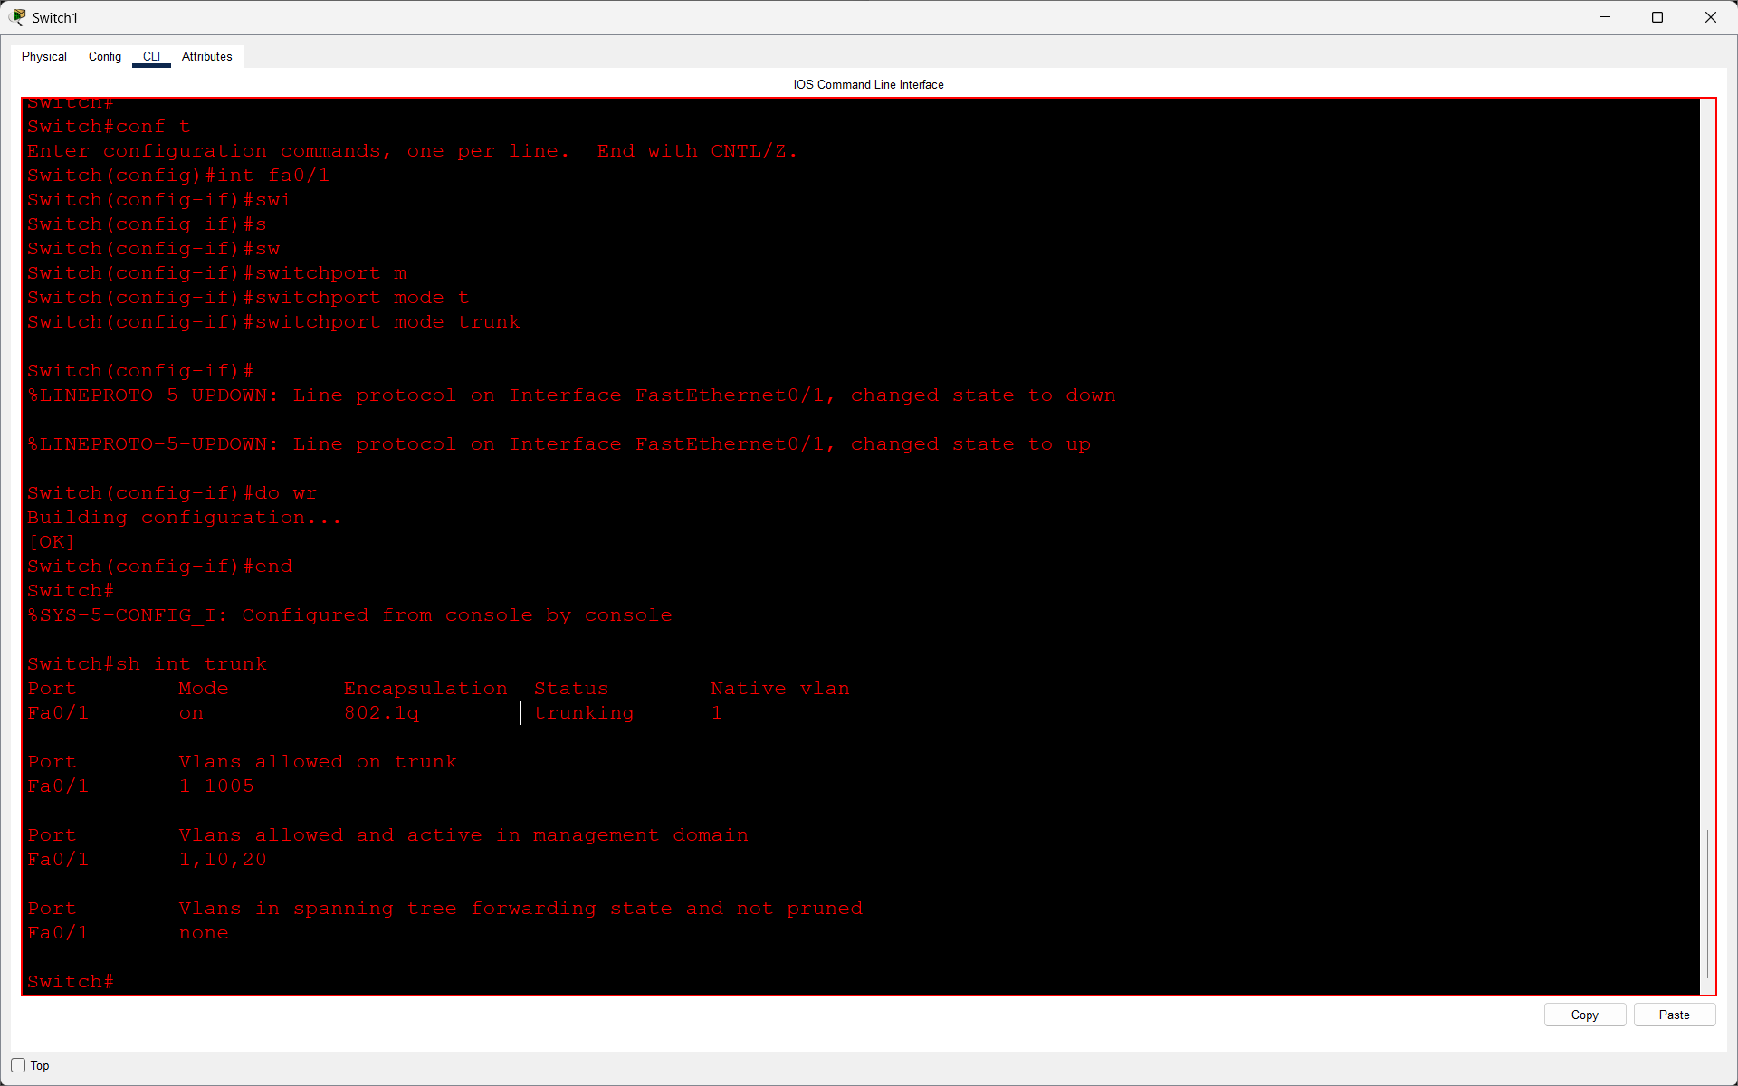
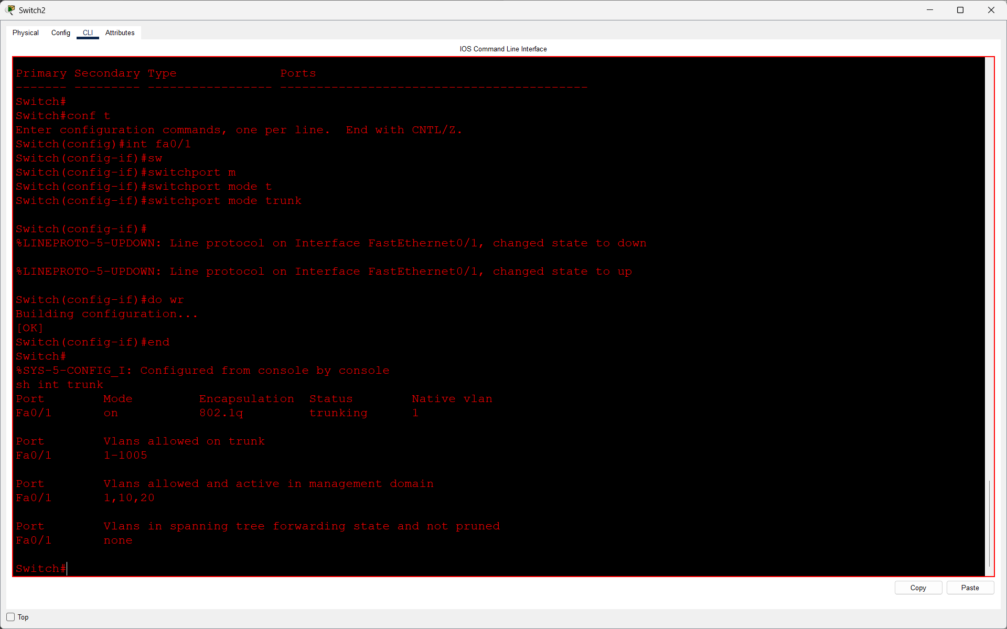

Q3. Set up a Layer 3 device (Router-on-a-Stick using a router or a multilayer switch) to enable inter-VLAN routing between VLAN 10 and VLAN 20. Assign appropriate sub-interfaces and IP addresses for each VLAN?

Answer
- I configured Router-on-a-Stick using a Cisco 2811 router and three switches.
- I created sub-interfaces for VLAN 10 and VLAN 20 using 802.1Q encapsulation and assigned IP addresses to them.
- I verified the router configuration using show ip interface brief and tested connectivity between different VLANs successfully.
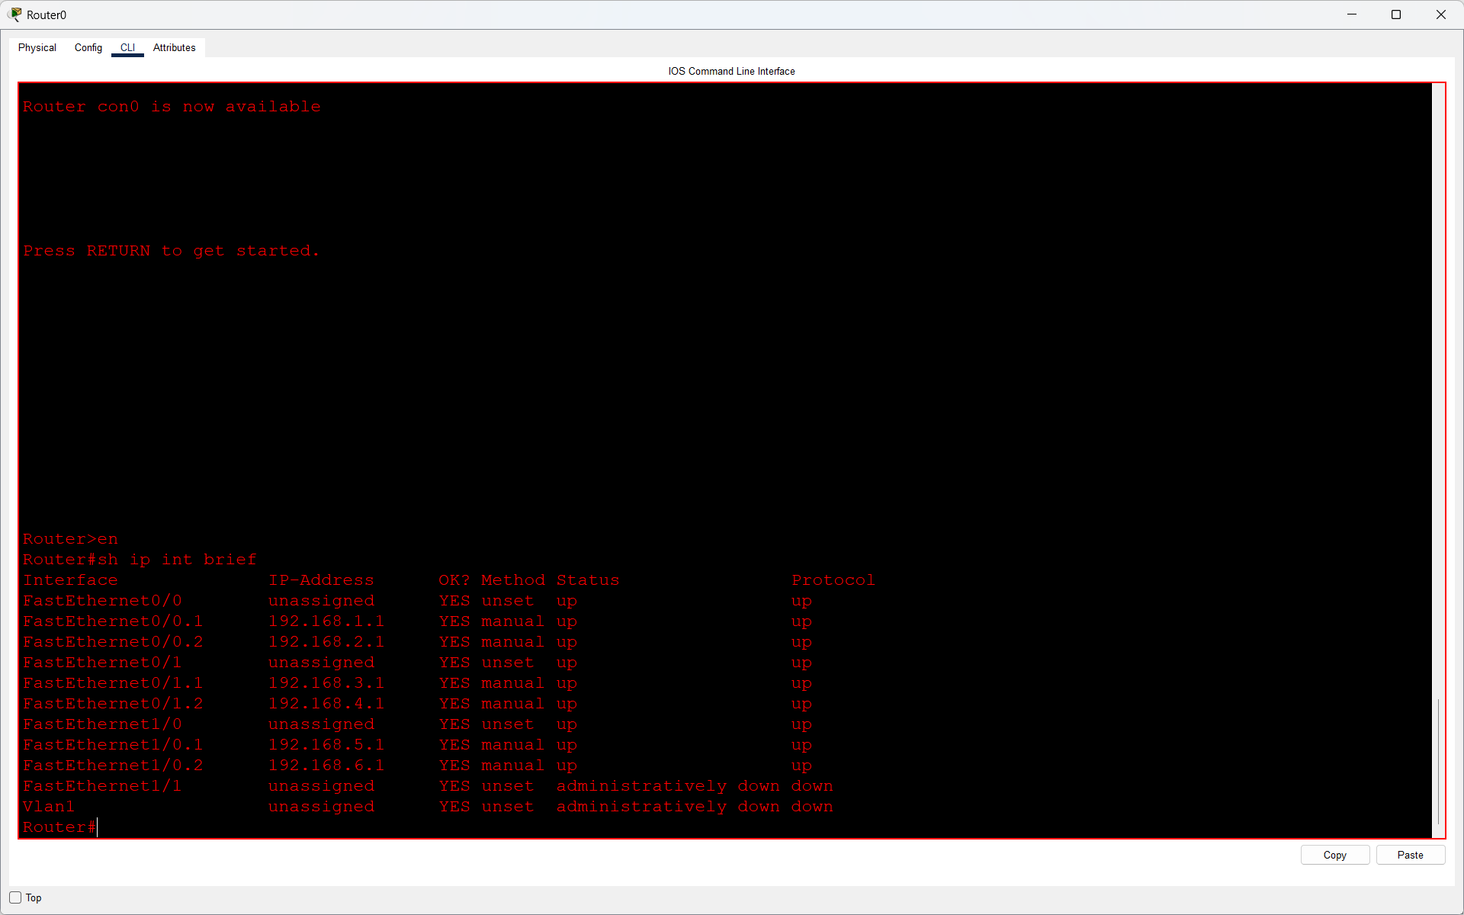
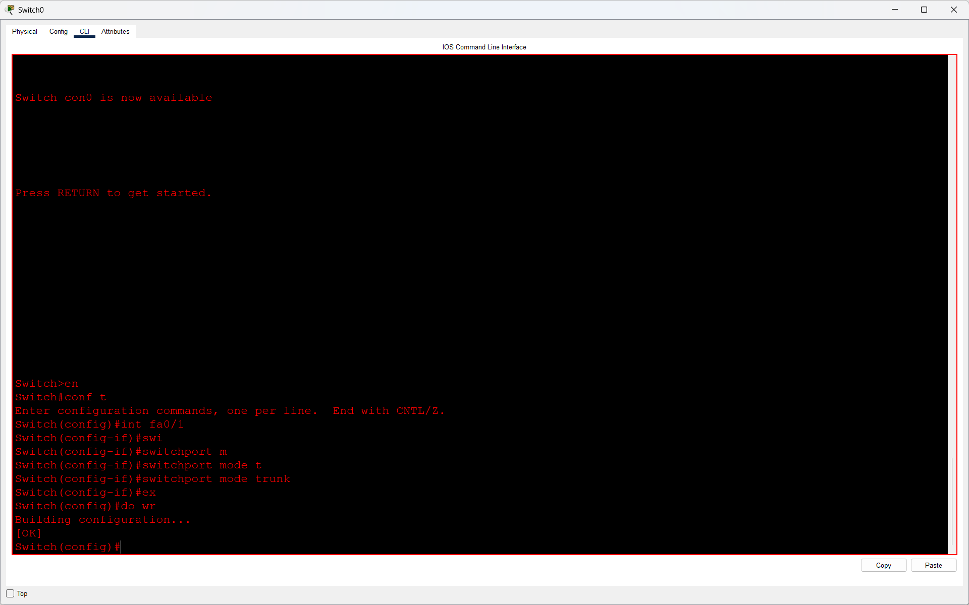

Q4. Test connectivity by pinging between a PC in VLAN 10 and a PC in VLAN 20. If pings fail, troubleshoot and fix the configuration so that inter-VLAN communication works.<br><br><em><strong>Hint:</strong> Check sub-interface IPs, trunk configuration, and default gateways on PCs.</em>?

Answer
- I tested inter-VLAN communication by pinging PCs from different VLANs in Cisco Packet Tracer.
- Initially, the ping failed. I checked the router sub-interfaces, trunk ports, IP addresses, and default gateways.
- After troubleshooting, I tested the connectivity again and the ping was successful.
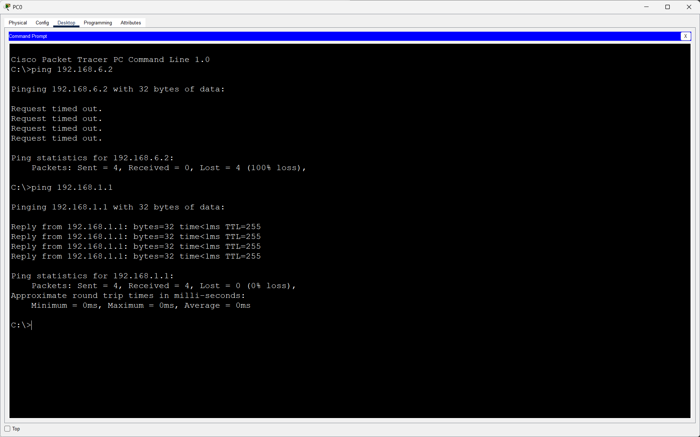
- Result: Inter-VLAN communication is working successfully.

